ADDB7311

ICE Task 5 – Users Pg 63

ST10305921 – Zoe Heyneke

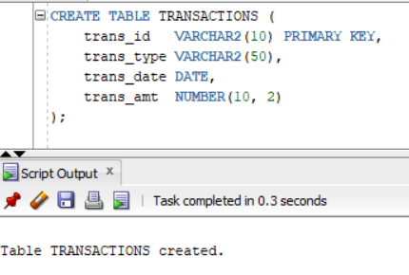

* Create User

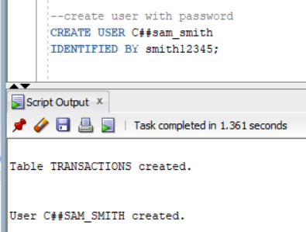

* Grant privelleges

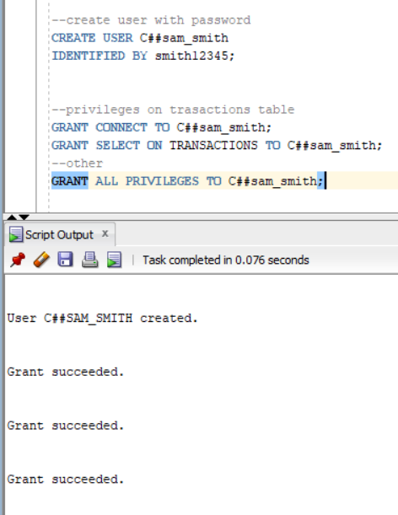

* Code:

CREATE TABLE TRANSACTIONS (

trans_id VARCHAR2(10) PRIMARY KEY,

trans_type VARCHAR2(50),

trans_date DATE,

trans_amt NUMBER(10, 2)

);

--create user with password

CREATE USER C##sam_smith

IDENTIFIED BY smith12345;

--privileges on trasactions table

GRANT CONNECT TO C##sam_smith;

GRANT SELECT ON TRANSACTIONS TO C##sam_smith;

--other

GRANT ALL PRIVILEGES TO C##sam_smith;